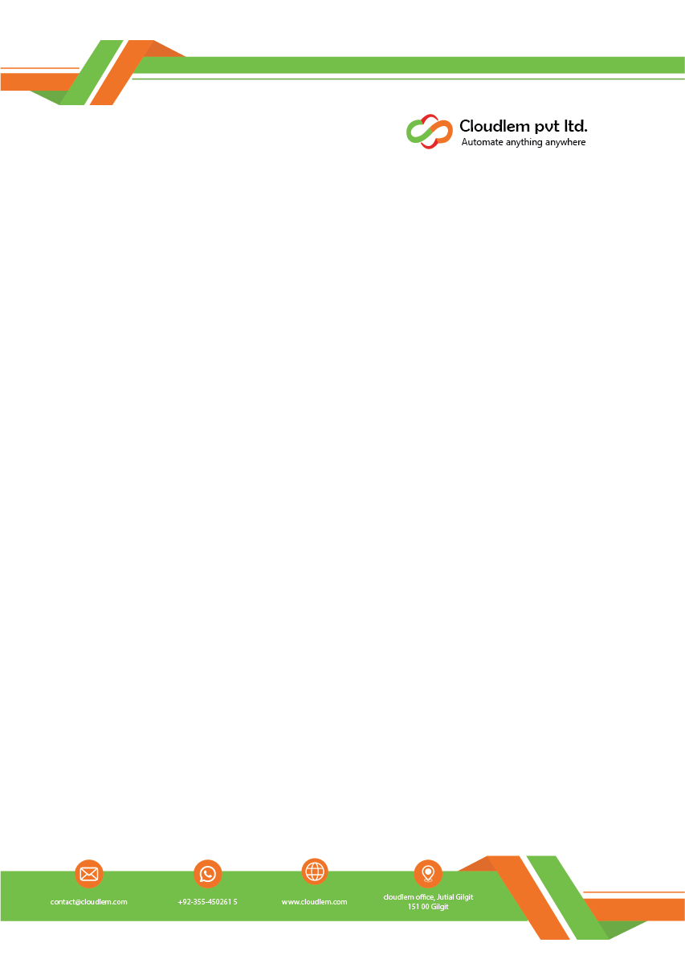

Date: 12 March 2026

Mohammad Arqam Javed
Subject: DevOps Internship Offer letter at Cloudlem
Dear Mohammad Arqam Javed,
Greetings from Cloudlem!
We are pleased to offer you the position of DevOps Intern at Cloudlem. This letter serves as confirmation of your selection for the DevOps Internship Program with a tenure from 17th March 2026 to 17th April 2026.
This internship is designed as a valuable learning opportunity, providing you with exposure to practical DevOps concepts and hands-on experience. During your tenure, you will undergo an orientation program and engage in various tasks aimed at enhancing your technical skills, problem-solving abilities, and understanding of real-world DevOps practices.
As an intern, you are expected to perform all assigned responsibilities diligently and professionally, adhering to lawful and reasonable directions provided by your mentors and supervisors.
We look forward to a mutually rewarding association and are confident that this internship will equip you with the knowledge and experience necessary for your future endeavors.

We wish you a productive, insightful, and enriching internship experience at Cloudlem.

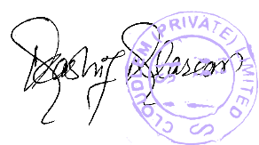
Sincerely,

Kashif
Founder & CEO

